***HOME OWNER’S GUIDE TO LAKE LIVING***

***BEST MANAGEMENT PRACTICIES FOR IMPROVED WATER QUALITY***

## **42.0782 N, 84.4245 W**

## 

## Mirror Lake Association

## 2024

## **Water Quality Best Management Practices (BMPs)**

## Best Management Practices (BMPs) are land management practices that treat, prevent, or reduce water pollution)

**YOU CAN HELP IMPROVE OUR WATER QUALITY!**

###### Purpose

Improving water quality after 50+years of residential development, chemical lake treatments, burning leaves and septic systems is a difficult task that requires a **multi-pronged approach** in order to reverse the eutrophication (excessive nutrients) in our lakes. All Members must do their part by using the on-shore Best Management Practices outlined in this brochure whenever possible.

Please review this brochure thoroughly and implement these practices whenever possible.

###### Contents

Water Quality On-Shore BMPs

Summary Natural Plantings Alternative Shoreline

***Water Quality (BMPs)***

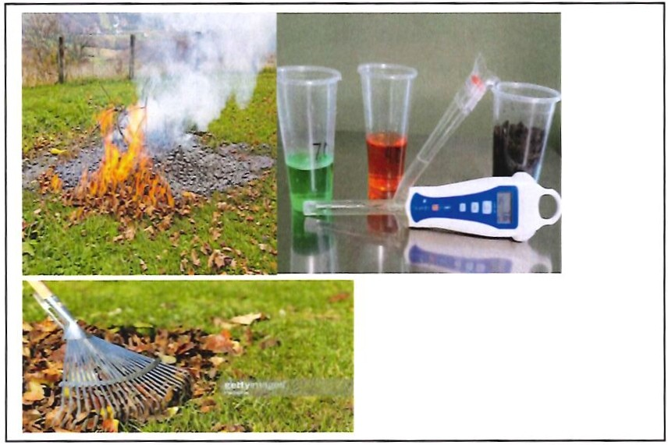

**FERTILIZER & SOIL TESTS:**

External use of chemical fertilizers contributes significantly to the nutrient loading (nitrogen & phosphorous) in our Lakes. Before any use of fertilizers, we recommend that members purchase a soil test kit ($15 - $25) to determine if there are deficiencies in the soil. The lake contains high levels of nutrients and watering lawns with lake water will supply nitrogen and phosphorous to lawns. We strongly encourage all members to "Skip the Fertilizer" if at all possible, or at a minimal reduce the number of applications required. If fertilizers are absolutely required as determined by test kits, only apply fertilizers or supplements that do not contain phosphorous. Use weed control or pesticides prudently if needed. Always maintain at least a 20-foot buffer zone to the water edge.

**LEAF BURNING & ASHES:**

The ash from burning leaves is a high source of phosphorous (nutrients). Phosphorus promotes growth of lawns and lake weeds. If the wind is blowing toward the lake, leaf burning will cause phosphorous (nutrients) to be directly deposited into the lake. Leaf burning will also leave higher levels of nutrients on the lawns, which will filter into the lake through run-off when it rains or as you water your lawns. Please be prudent if burning leaves is necessary.

***Water Quality (BMPs) (Continued)***

**RAKING LAKEFRONTS:**

Please take advantage of the spring and fall to aggressively rake your beachfront to remove decaying leaves, and other debris. The decaying process of these items depletes the lake and fish of dissolved oxygen and can cause an increase in the temperature of the lake water. Raking leaves and debris from your waterfront discourages nuisance weed growth.

**LEAF DISPOSAL:**

After raking, leaves must be removed from the property so that nutrients from the decaying leaves do not wash into the lake.

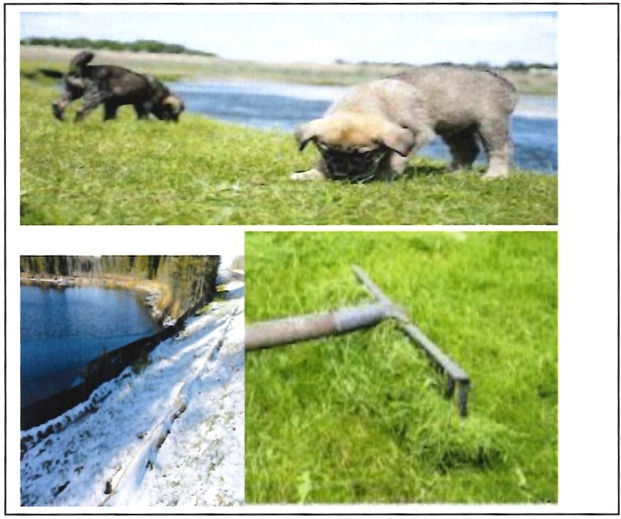

**ANIMAL & BIRD WASTE**:

Members should clean- up pet waste immediately from their yard and **never feed geese**. Waste from pets, birds and other animals can contain aerobic bacteria that consumes oxygen in the process of decomposition. Pet, bird and animal waste if washed into the lake can also deplete dissolved oxygen from our lake. Please pick-up pet, bird and animal waste often.

***Water Quality (BMPs) (Continued)***

**LAWN CLIPPINGS;**

Minimize lawn clippings when mowing your lawn. Lawn clipping can carry fertilizer into the lake with them and also decay in the lake. Please collect and dispose of lawn clippings whenever possible.

**SOIL EROSION PREVENTION**

Minimize soil erosion during any landscape projects or construction work by installing erosion barrier (black fabric) at the lakeshore. Soil erosion can increase the suspended solids in the lake, which causes the water to become cloudy. Cloudy, turbid water absorbs the sun's rays and gets warmer. Water temperatures greater than **68 degrees will foster weed (Algae) growth**

**WASTE WATER DISCHARGE:**

Do not directly or indirectly discharge any liquids, pool water, water softener discharge or substances which may be harmful to the water quality of the lake. Such discharges should be directed into the property owner’s septic field/tank. Please refrain from using any bio-degradable products in the lake. They leave chemicals in the water!

***Water Quality (BMPs) (Continued)***

**(REMEMBER)**

**(Only 1 lb. of phosphorous, 7 lbs. of nitrogen, and 40 lbs. of carbon is required for a 500 lbs. batch of wet algae to bloom on our lakes.)**

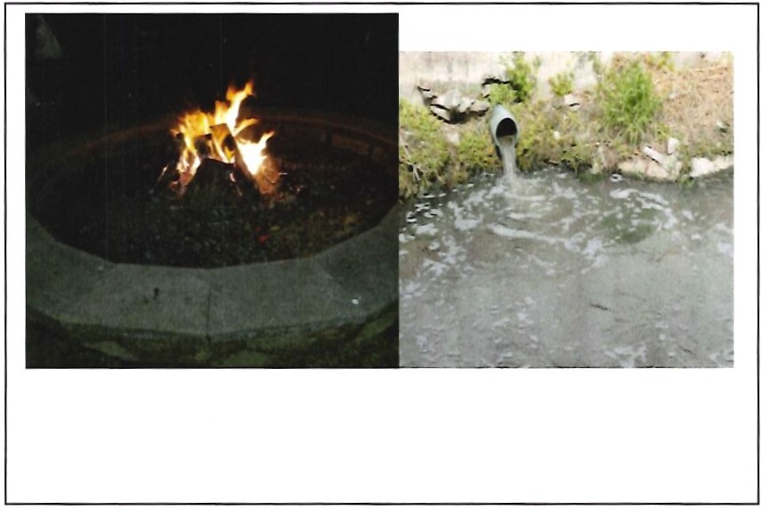

**STORM DRAINS**

There are numerous storm drains and artesian wells that feed into our lake. Never put anything into a storm drain. This includes waste water and any type of soaps or chemicals. Doing so will diminish the quality of the lake water and could pollute areas of the lake.

**NEW FIREPITS:**

All fire or bonfire receptacles/enclosures should be located a minimum of 20-feet from the shoreline. Keeping all New Fire pits away from the shoreline will provide a buffer zone to protect our lake from any ashes or run-off, which causes phosphorous nutrient loading into the Lake.

**ALL FIREPITS:**

Regardless of the distance from the shoreline, any open fire or bonfire receptacle/enclosure located on any lakefront property should be in a self-contained fireproof receptacle or enclosure made of brick, stone, masonry, steel or earthen base where the ash can be confined, collected, and disposed of properly when cooled. Ashes should be removed and deposed of prior to rain storms.

Ashes that leach into the Lake causes nutrients loading (phosphorous) to flow into the lake. Doing so directly contributes to the growth of algae blooms.

**GREY WATER DISCHARGE:**

Do not discharge any washi ng machine wastewater or water softener discharge directly into the lake. Doing so will increase nutrients and contribute to algae bloom.

***Water Quality (BMPs) (Continued)***

##### ABOUT SEPTICS SYSTEMS

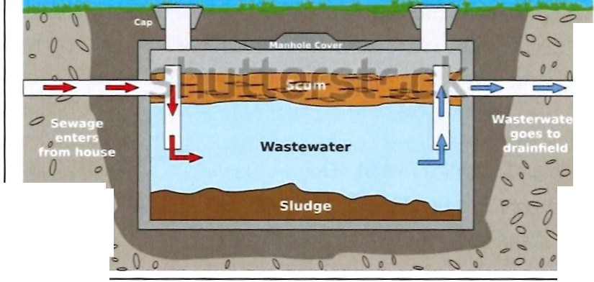

**Septic Tank Diagram**

_.._.

_.._.

Q

.".

ltJ *t:7* " *'>:::J*

I *0*

..

" """ *t?*

*tl o*

=

*0*

' ..

*0* =

, *J*

0 "::.

_

...

"'

* Generally, you can plan to have the tank pumped approximately every 3 to 5 years. Just like changing the oil in your car, preventive septic system maintenance will extend the life of your system for a small cost compared to the cost of replacing the system.
* Malfunctioning septic systems release bacteria, viruses, and chemicals toxic to local waterways.
* When these pollutants are released into the ground, they eventually enter streams, rivers, and lakes.
* The frequency of pumping the septic tank depends on the tank size, number of people in the household, habits of water use as well as the amount of solids accumulated in the tank.
* Spring is a great time to service your septic system.
* If your drain field is more than 25 to 30 years old, the natural bio mats that forms in the bottom of the trenches or beds can thicken and reduce the ability of the drain field to properly discharge wastewater into the ground.
* If your septic system is more than 25 to 30 years old, start planning for an upgrade. It is likely your system is close to its useful lifespan.
* The best way to extend the life of your system is through proper maintenance.

## **Alternative Shoreline (BMPs)**

## **Natural Native Plantings to Protect Shoreline and Improve Water Quality**

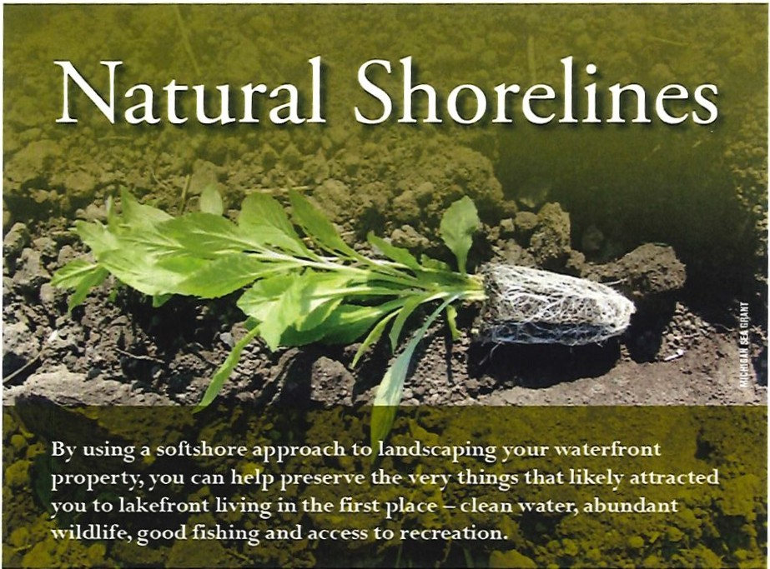

Homeowners and lake stewards can help keep their lakes healthy by using ecological principles to assess, design, construct and maintain natural shorelines.

**WHY CONSIDER A NATURAL SHORELINE?**

The primary purpose of a buffer at the shoreline is to protect the property from erosion. Erosion may result in loss of shoreline property and increased sediment in the water -leading to poor water quality.

**WHAT IS BIOENGINEERING?**

Bioengineering, often called soft shore engineering or lakescaping, is a method of using native plants, biodegradable products and other natural materials to provide a stable shoreline. The goal is to protect the property from waves and erosion, while improving ecological features and the integrity of the shoreline. Bioengineering methods are often used when creating natural shoreline – which acts as a living buffer that changes throughout the seasons and years. Natural shorelines are a critical component of a healthy lake, and a well-designed bioengineered shoreline can balance lake access, views, aesthetics, and lake health.

**Advantages of installing shoreline bioengineering:**

* Erosion Control Bioengineering stabilizes the shoreline by utilizing native plants with strong, deep rooting, and complex root systems that hold soil and sediment and protect the shoreline from erosion.

* Improved Water Quality Bioengineering uses native plants to intercept nutrients and pollutants before they enter the lake, leading to clearer water and decreased algal blooms.
* Fish and Wildlife Habitat Bioengineering provides clean water, cover, feeding habitat for fish; nesting, basking, and feeding habitat for turtles, frogs, birds, butterflies, and other wildlife. Bioengineering also deters property damaging geese!

**TIRED OF GEESE IN YOUR YARD?**

Maintaining a vegetated strip along the shore can act as a natural deterrent for Canada geese. Taller plants like native grasses, wildflowers and shrubs (2-3 feet tall) along the shore are less inviting to the geese, which favor open expanses of manicured lawns and unrestricted access to the lake shore.

Please refer to the publication Natural Shorelines for Inland Lakes for the entire article regarding this topic.

***https://www.michigan.gov/-/media/Project/Websites/egle/Documents/Programs/WRD/Inland-Lakes-and-Streams/natural-shorelines-inland-lakes.pdf***

Heath Measures:

* 36% of lakes nationwide have been graded with “poor” lakeshore habitat.
* Lakes with poor surrounding vegetation are about three times more likely to also have poor biological conditions.

*U.S. Environmental Protection Agency – National Lake Assessment*

***Natural Shoreline Protection Native Plantings***

Source: Natural Shorelines for Inland Lakes produced by the Michigan Sea Grant and the Michigan Department of Environmental Quality

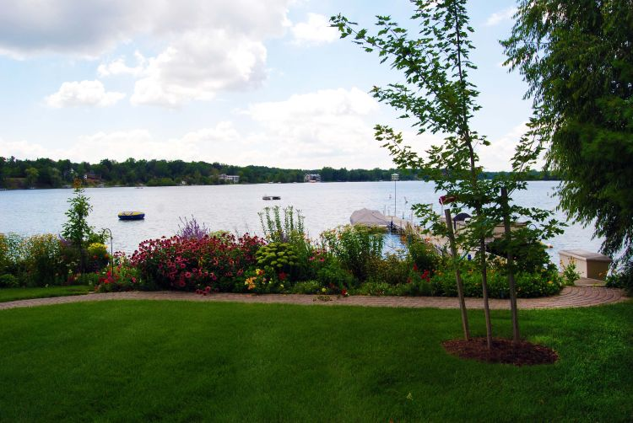

**WHAT ARE NATIVE PLANTS?**

Native plants are grasses, flowers, shrubs and trees that are indigenous to a particular area. A few reasons to use native plants:

* + Native plants provide food and habitat for birds and other wildlife, and they help maintain natural biodiversity.
  + Since they are adapted to living in their native territory, native plants require minimal maintenance and watering once established. Many are perennial.

**ALONG YOUR SHORELINE**

Planting is a relatively easy, affordable and attractive way of incorporating bioengineering into lakeshore design. Native plant species, which are well adapted to local climate and soil conditions, are particularly good options for landscaping. The use of native plants can have significant positive benefits for the lake and the shoreline.

For example, plants that overhang and create shade improve water quality for fish, waterfowl and other aquatic life by providing food close to the water's edge.

A vegetated buffer along the shore can also help absorb the extra nutrients (like those from fertilizers) and pollutants in surface runoff as the water drains to the lake.

### **THE EFFECTS OF EROSION**

The cumulative effects of shoreline erosion on individual lots can have widespread impacts on lake water quality. When soil erodes from shorelines into the lake, it causes sedimentation, leading to increased cloudiness and reduced sunlight penetration in the water. This affects aquatic plants, disrupting the lake’s natural balance. Additionally, the eroded soil often carries nutrients like phosphorus and nitrogen into the lake, leading to nutrient overload. This excess of nutrients can trigger [algal blooms](https://www.nrdc.org/stories/soil-erosion-101#water), which, when decomposed, consume oxygen and create harmful conditions for fish and other aquatic life. Moreover, the s[edimentation can smother the lake’s bottom habitats](https://files.dnr.state.mn.us/publications/waters/shoreline_alterations_lakescaping.pdf), negatively affecting organisms living there. Addressing and preventing shore erosion is crucial for maintaining the overall health and stability of lake ecosystems.

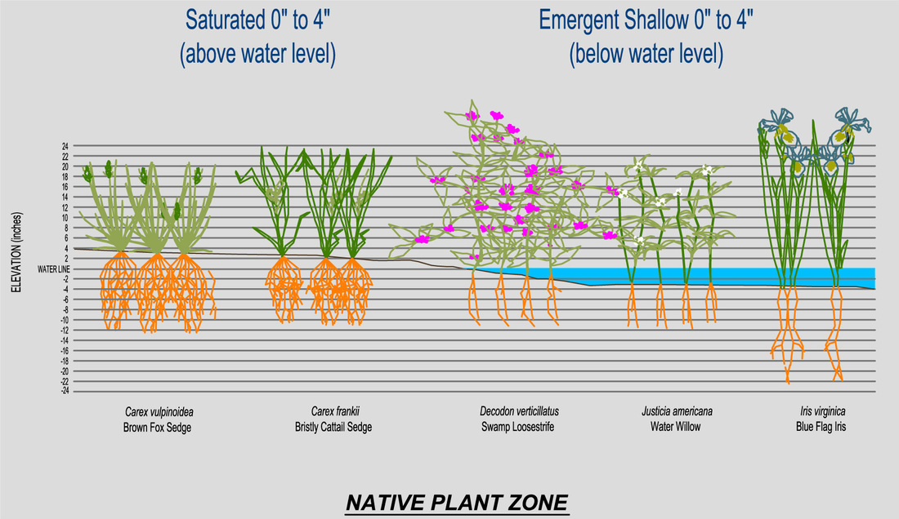

**Four Different Zones:**   
 The plants have been placed in each category based on their suitability for the water levels and other variables such as wave action.   However, once these plants have been planted they may “move” into a different area.  This is because natural conditions at each particular site are highly variable, and each plant will find specific areas most suitable for their growth.   
 **Below The Water Level:**

* These are the plants that are found in the aquatic zone.  Use these plants for planting areas within the lake.

**Between the Water Level and the Ordinary High Water Mark:**

* These plants like it wet but do not like to actually be in the lake.  They can handle frequent water level changes ranging from being flooded for days at a time to being dry for short periods of time.  These plants are also the best ones to withstand the energy from wave action and ice push.

**Above the Ordinary High Water Mark:**

* These plants are still considered wetland plants but they are typically further from the lake edge.  They like the soil to be consistently moist and they can handle a small amount of flooding.  They do not like the constant stress that comes from waves and ice.

**Upland Plants:**

* These plants like dry conditions.  This section was included to provide homeowners with native plant suggestions to use in the remaining part of the landscape to allow for opportunities for a comprehensive landscape design.

For more information: <https://www.shorelinepartnership.org/find-native-plants.html>

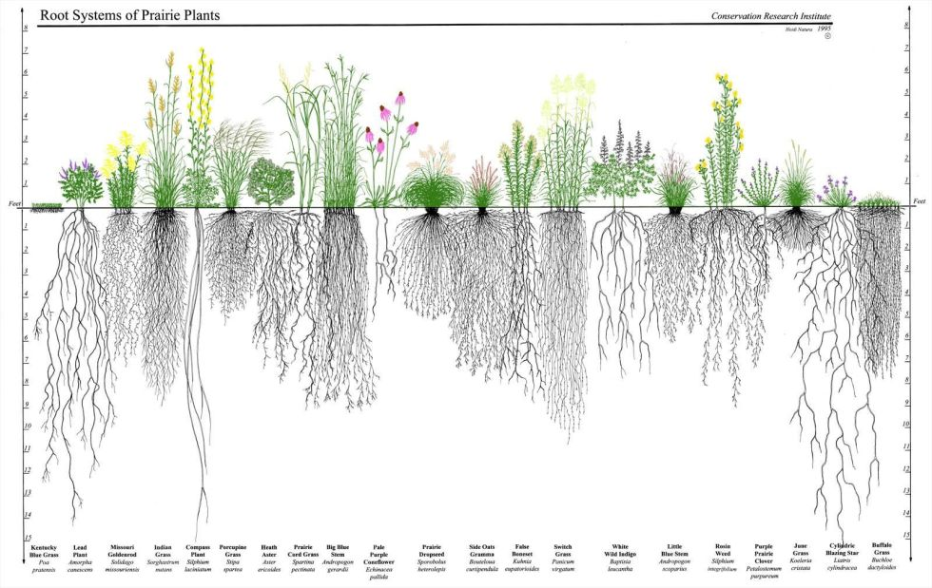

*LOVE MIRROR LAKE*



*ALWAYS USE BEST MANAGEMENT PRACTICES*

Questions: Contact Doug Collins

724-968-1700

Doug.Collins@comcast.net